Another Montgomery
*** REAL ESTATE ***
AUCTION
Lovely Cottage, 5 Lots
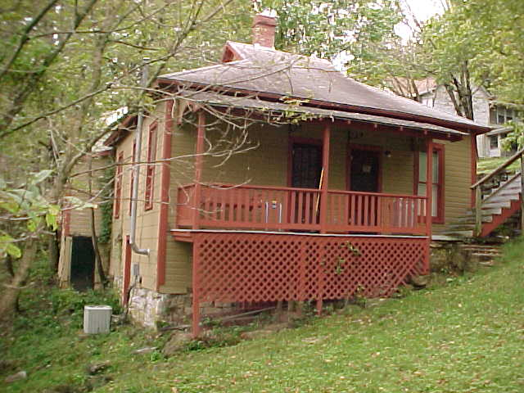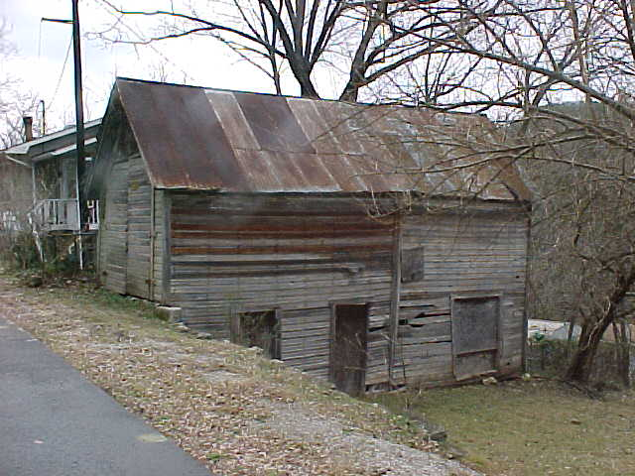
Eureka Springs Arkansas
17 Cliff Street
Location of Auction: On the premises ---From downtown, follow
North Main and turn left on Mountain; then right on Cliff
Friday September 10, 2010 6 pm

A lovely cottage with the charm of “Yesteryear”. It has central heat & air,
A forties refrigerator, a bath with an old fashion tub and a nice setting porch.
Included is a 2 story barn!
All this within walking distance of Historic Downtown Eureka Springs.

TERMS: $10,000 down day of sale with the balance to be paid in certified funds at closing.
Opportunity Knocks!! Don’t miss this one!!

To view this property or for terms, conditions, and other information, contact Larry Montgomery,
870 423-2997, agent for the seller, or view our web site www.Lmontgomeryauction.com .
Ross Sackett Estate
Larry Montgomery Broker / Auctioneer
 Exit Montgomery Whiteley Realty
Berryville, Arkansas AALB # 95
870 423-2997 larry@lmontgomery.com

